PIZZA SALES SQL QUERIES

A.KPI’s

1.Total Revenue:

select SUM(total_price) AS Total_Revenue from pizza_sales

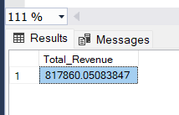

2.Average order Value:

Select SUM(total_price)/ COUNT(DISTINCT order_id) AS Avg_order_value from pizza_sales

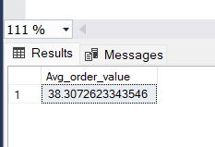

3.Total Pizza Sold:

select SUM(quantity) AS Total_Pizza_Sold FROM pizza_sales

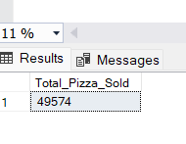

4.Total Orders

select COUNT (DISTINCT order_id) AS Total_Orders from pizza_sales

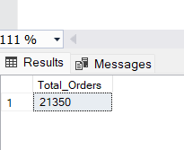

5.Average Pizza Per Order

select CAST (SUM(quantity) AS DECIMAL(10,2))/

CAST(COUNT(DISTINCT order_id) AS DECIMAL(10,2)) AS avg_Pizzas_per_order from pizza_sales

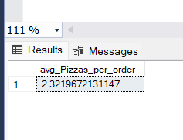

**PROBLEM STATEMENT**

CHART REQUIREMENTS

1.Daily trends for total orders:

select DATENAME(DW, order_date) as order_day, COUNT(distinct order_id) AS Total_orders from pizza_sales

GROUP BY DATENAME(DW, order_date)

#DATENAME is use to derive date of the WEEK

#DW- It Retrieves the Day of the WEEK as a character string like Sunday, Monday………..

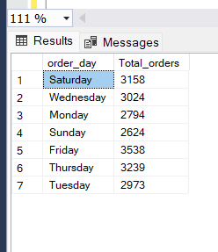

2.Monthly trend for total orders;

SELECT DATENAME(MONTH, order_date) AS Month_Name, COUNT(DISTINCT order_id) AS Total_Orders

FROM pizza_sales

GROUP BY DATENAME(MONTH, order_date)

ORDER BY Total_Orders DESC;

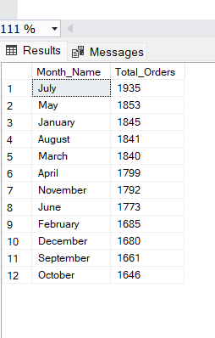

3. Category wise pizza total sales and their sell %

SELECT pizza_category, sum(total_price) as Total_Sales ,sum(total_price)* 100/ (SELECT sum(total_price) from pizza_sales WHERE MONTH(order_date)=1) AS Percentage_of_Total_Sales

from pizza_sales

WHERE MONTH(order_date)=1

GROUP BY pizza_category

#this code is showing month wise result= sales WHERE MONTH(order_date)=1

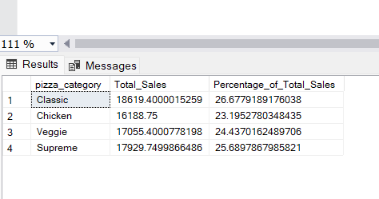

4.Percentage of sales by Pizza Size:

SELECT pizza_size,SUM(total_price) as Total_Sales, sum(total_price)* 100/ (SELECT sum(total_price) from pizza_sales WHERE MONTH(order_date)=1) AS PCT

from pizza_sales

WHERE MONTH(order_date)=1

GROUP BY pizza_size

ORDER BY PCT DESC

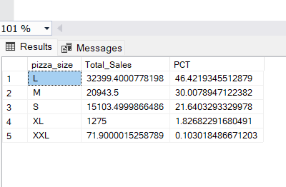

5.Top 5 Best sellers by Revenue ,Total quantity and Total Orders:

# BY REVENUE

select top 5 pizza_name, sum(total_price) as total_Revenue from pizza_sales

group by pizza_name

order by Total_Revenue DESC

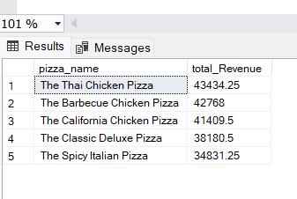

#BY QUANTITY

select top 5 pizza_name, sum(quantity) as total_quantity from pizza_sales

group by pizza_name

order by total_quantity DESC

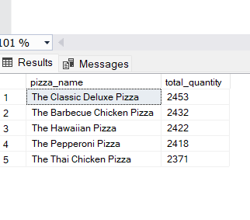

#BY TOTAL_ORDER

select top 5 pizza_name,count (distinct order_id) as total_orders from pizza_sales

group by pizza_name

order by total_orders DESC;

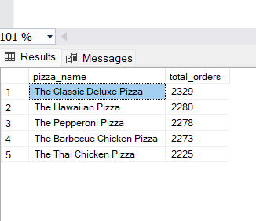

6. Bottom 5 Pizza Best sellers by Revenue ,Total quantity and Total Orders:

#BY REVENUE

select top 5 pizza_name, sum(total_price) as total_Revenue from pizza_sales

group by pizza_name

order by Total_Revenue ASC

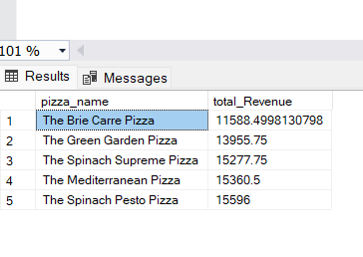

#BY QUANTITY

select top 5 pizza_name, sum(quantity) as total_quantity from pizza_sales

group by pizza_name

order by total_quantity ASC

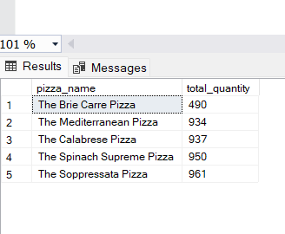

# BY TOTAL_ORDER

select top 5 pizza_name,count (distinct order_id) as total_orders from pizza_sales

group by pizza_name

order by total_orders ASC;

